**Code Inspection Summary**

**Team 9 Details:**

Pavan Kalyan Kudidala (11705031)

SaiNithin Sindhe Damaragidda (11705464)

Uday Kalyan Nuthalapati(11727451)

Vishal Miyapuram (11702151)

Shravani Kasula (11698782)

Keerthi Lekkala Dilli (11703021)

Abhishke Kotrike (11712114)

Sai Venkata Nithyananda Reddy (11696613)

**Core Functionalities:**  
  
Job Description:

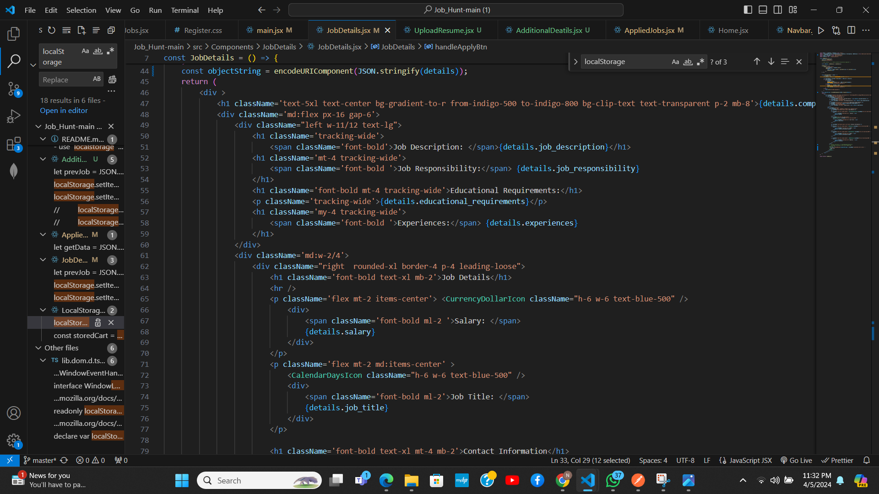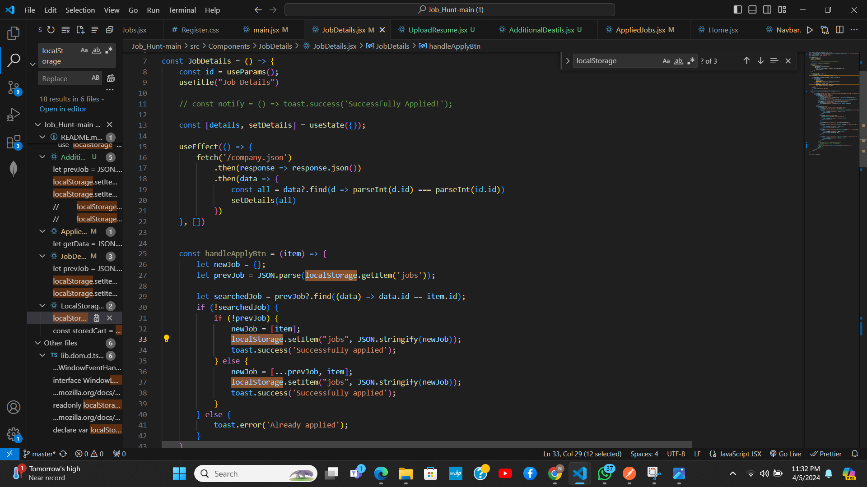

A job description serves as a crucial communication tool between employers and job seekers. It outlines the duties, responsibilities, qualifications, and expectations associated with a particular job role. In the context of Job Hunt, job descriptions play a pivotal role in helping users understand the requirements and responsibilities of various job openings.

A well-crafted job description typically includes several key components. Firstly, it provides a clear and concise job title that accurately reflects the role. This title helps job seekers identify relevant positions quickly. Next, the job description outlines the primary duties and responsibilities associated with the role. This may include tasks such as project management, software development, customer service, or marketing activities.

Furthermore, a job description specifies the required qualifications and skills necessary to excel in the role. This may include educational background, work experience, technical proficiencies, and any additional certifications or credentials desired by the employer. Additionally, it may highlight specific competencies or soft skills such as communication, teamwork, problem-solving, and adaptability.

Moreover, job descriptions often include details about the company or organization, its culture, mission, and values. This information helps job seekers gauge whether the company aligns with their career aspirations and values. It also provides insights into the company's industry, products, services, and potential career growth opportunities.

In summary, job descriptions on Job Hunt serve as essential resources for job seekers, providing comprehensive insights into available job opportunities, their requirements, and the organizations offering them. By crafting detailed and accurate job descriptions, employers can attract qualified candidates who are well-suited to meet their organizational needs and goals.

Applying for Jobs(**Application Submission Handling:**):

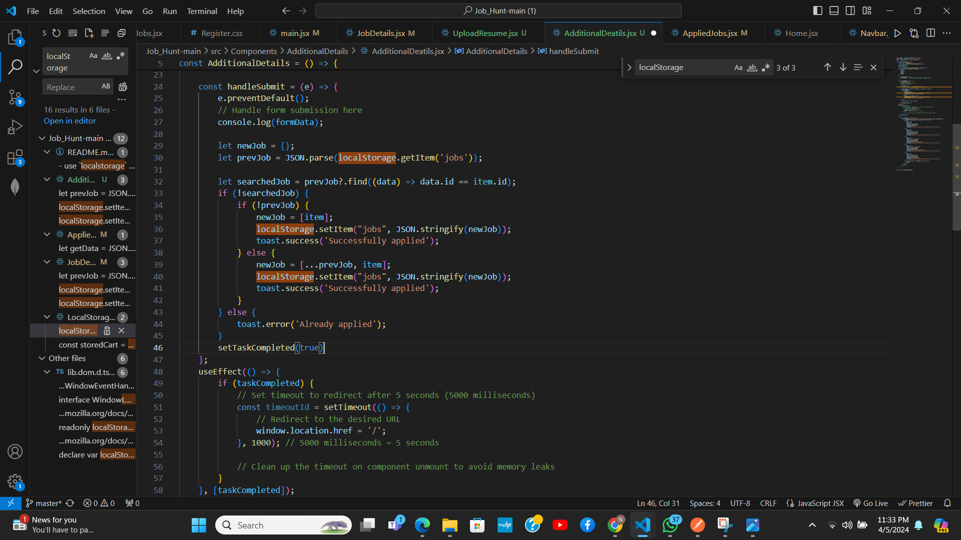

Applying for jobs on Job Hunt is a straightforward process designed to streamline the job application process for both employers and job seekers. The platform offers intuitive features and functionalities that facilitate seamless job applications while maximizing the chances of success for applicants.

To apply for a job on Job Hunt, users first need to create an account or log in to their existing account. Once logged in, they can browse through the list of available job openings using various search filters such as location, job title, industry, and keywords. Users can also save job listings for future reference or set up job alerts to receive notifications about new job postings matching their preferences.

When users find a job listing that interests them, they can click on the job title to view the complete job description and requirements. After reviewing the job details and ensuring they meet the necessary qualifications, users can proceed to submit their application.

The application process typically involves uploading a resume, cover letter, and any additional documents or portfolio samples requested by the employer. Job Hunt provides a user-friendly interface for uploading documents, allowing users to easily attach relevant files from their computer or cloud storage.

Once the application is submitted, Job Hunt sends a confirmation email to the applicant, acknowledging receipt of their application. The employer then receives the application through the platform's backend system, where they can review and manage all incoming job applications efficiently.

Overall, applying for jobs on Job Hunt is a seamless and user-friendly experience, empowering job seekers to explore diverse job opportunities and take proactive steps towards advancing their careers.

Job Hunt FAQ’s

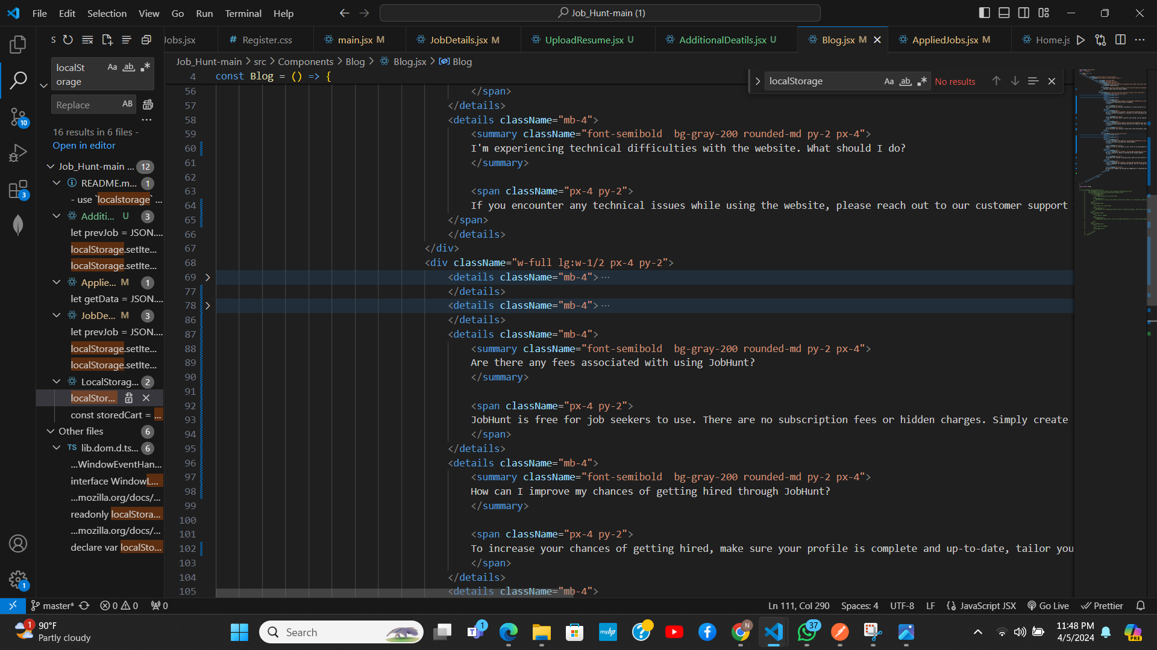

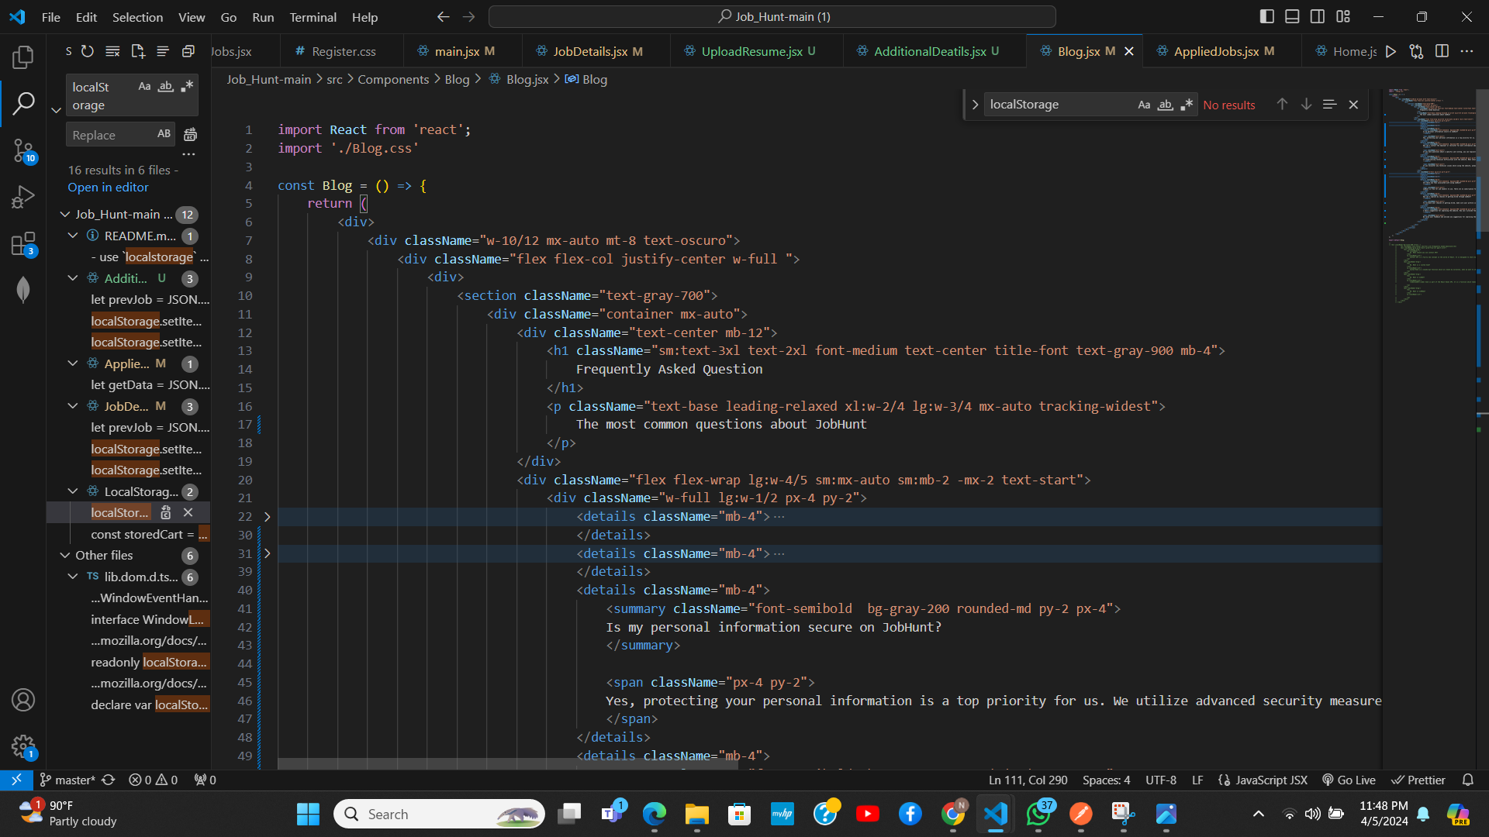

Job Hunt's FAQ section is a comprehensive resource designed to address common queries and concerns that users may have about the platform's features, functionalities, and best practices for job searching.

The FAQ section aims to provide clear and concise answers to help users navigate the platform effectively and make informed decisions throughout their job search journey.

The FAQ section covers a wide range of topics relevant to job seekers, including:

**Account Setup and Profile Creation:** Guidance on creating a Job Hunt account, setting up a user profile, and optimizing profile visibility to attract potential employers.

**Job Search Strategies**: Tips and techniques for conducting an effective job search, including utilizing search filters, refining search queries, and setting up job alerts.

**Application Process**: Step-by-step instructions on how to apply for jobs on Job Hunt, including uploading resumes, cover letters, and additional documents.

**Networking and Communication**: Advice on networking strategies, connecting with recruiters and industry professionals, and communicating effectively through the platform's messaging features.

**Privacy and Security**: Information about Job Hunt's privacy policies, data protection measures, and best practices for safeguarding personal information.

**Technical Support:** Resources for troubleshooting common technical issues, accessing help documentation, and contacting customer support for assistance.

By providing comprehensive answers to frequently asked questions, Job Hunt aims to empower users with the knowledge and resources they need to navigate the job search process with confidence and success.

**Job Application Management:**  
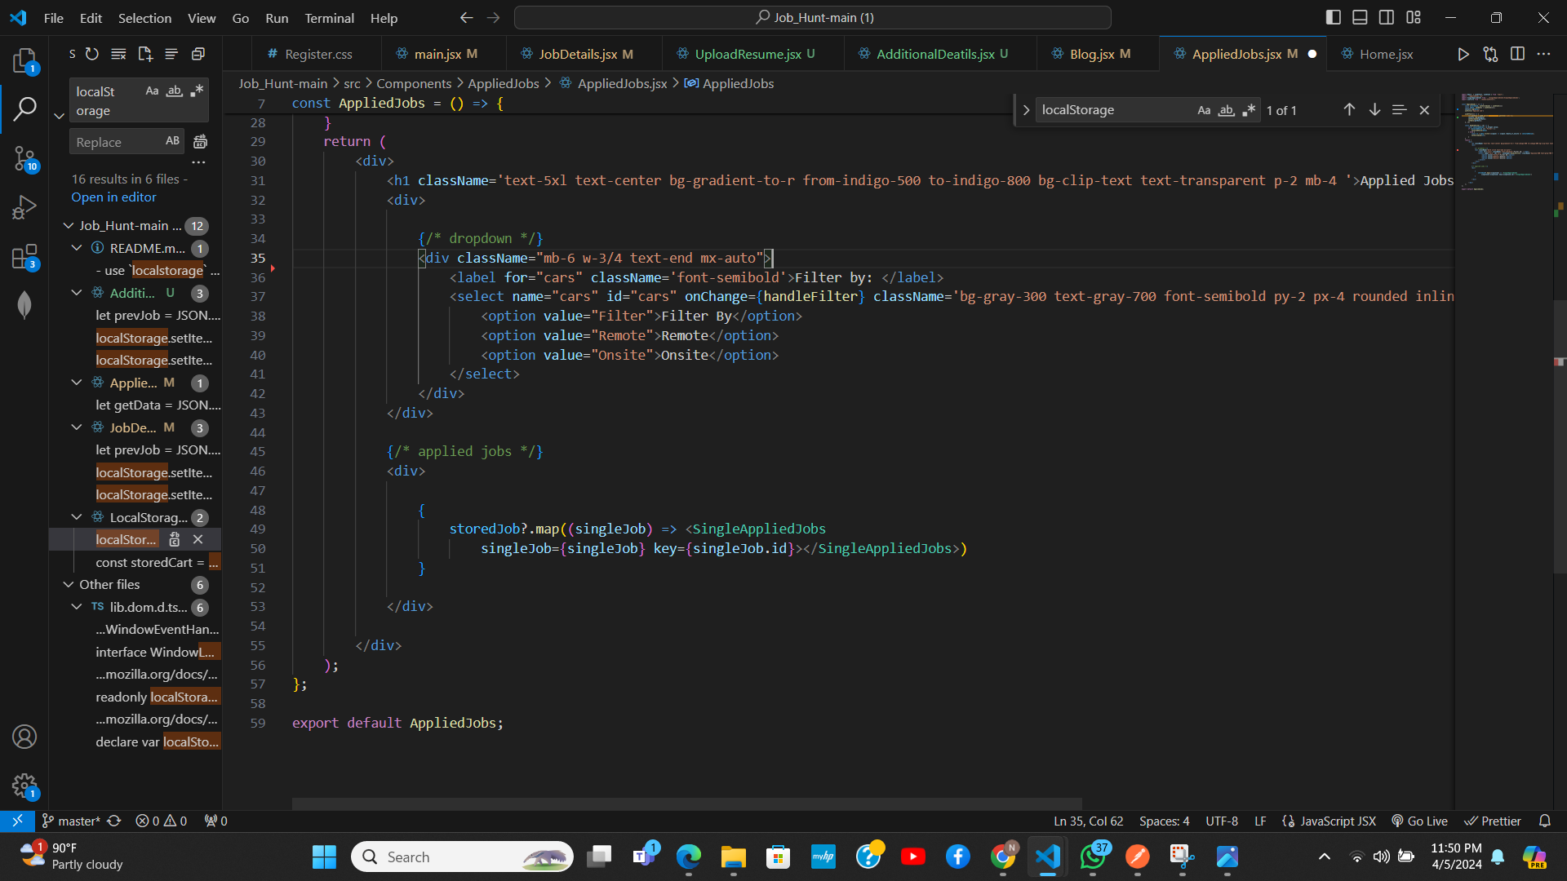

**Collecting Additional Details :**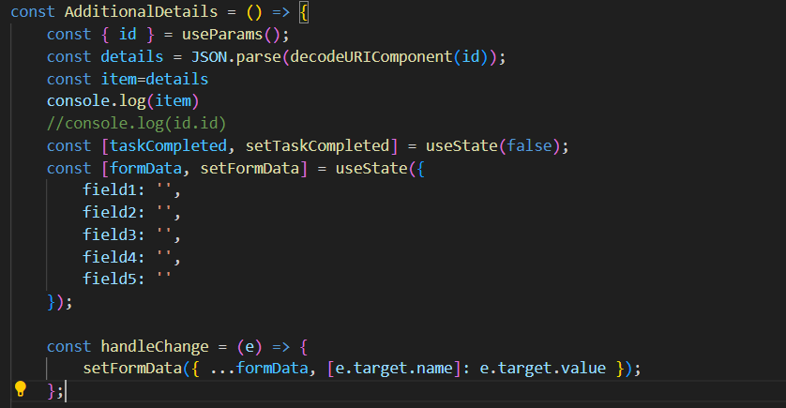

**Objective:**

The Additional Details functionality aims to collect essential additional information from users before they apply for a job. If the user has previously provided these details, the system retrieves the existing information and allows the user to review and edit it as needed.

**Features:**

**Collect Additional Information:**

Users are prompted to provide additional details such as contact information, education background, work experience, skills, and preferences.

The system presents a user-friendly form for users to input the required details.

Mandatory fields are clearly indicated to ensure complete submission of essential information.

**Retrieve Existing Details:**

If the user has previously provided additional details, the system retrieves the stored information from the database.

The retrieved details are displayed to the user for review and potential editing.

**Edit Details:**

Users have the option to edit the pre-filled details or update any information that may have changed since their last submission.

The system allows users to modify individual fields or sections of the additional details form.

Users can make changes with ease and confidence, knowing that their updates will be reflected in their job applications.

**Save Changes:**

After reviewing and editing the details, users have the option to save their changes.

The system updates the user's profile or database record with the revised information, ensuring accuracy and completeness.

**Schema Design:**

**Entities (Tables):**

* **User** table stores information about registered users.
* **Job** table contains details about available job listings.
* **Application** table tracks job applications submitted by users.

**Attributes (Columns):**

* **User** table includes attributes like user_id (primary key), username, email, etc.
* **Job** table has attributes like job_id (primary key), title, company, location, etc.
* **Application** table contains attributes like application_id (primary key), user_id (foreign key referencing the User table), job_id (foreign key referencing the Job table), etc.

**Relationships:**

The text mentions foreign keys, which are not explicitly shown in the image but are implied based on how the tables connect. The Applications table likely has a foreign key referencing the Users table (user_id) and a foreign key referencing the Jobs table (job_id). This design establishes a relationship between applications, users, and jobs. A single application connects a specific user (user_id) to a specific job listing (job_id).

**Indexing Strategies:** 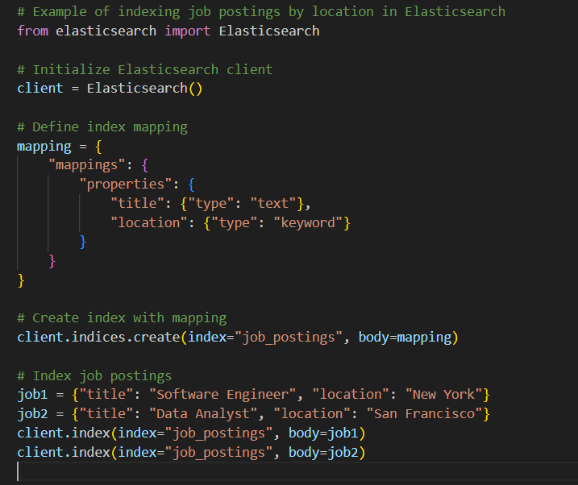

In the context of Job Hunt, Elasticsearch is utilized for efficient indexing and search functionality, enabling users to discover relevant job listings quickly and effectively. Here's an overview of indexing strategies using Elasticsearch:

**Job Indexing:** Job listings are indexed in Elasticsearch to enable fast and accurate search capabilities. Each job listing is indexed as a document, with fields representing attributes such as job title, company name, location, description, requirements, etc.

**Text Analysis**: Elasticsearch employs text analysis techniques such as tokenization, stemming, and stop word removal to preprocess and index textual data effectively. This ensures that job listings can be searched based on keywords while accounting for variations in language and terminology.

**Mapping Configuration**: Elasticsearch mapping configurations are defined to specify the data types and index settings for each field in the job documents. This includes specifying fields as text, keyword, date, numeric, etc., and configuring properties such as analyzer, index options, and fielddata settings.

**Indexing Pipeline**: Custom indexing pipelines may be created to perform additional processing on job listings before indexing. For example, HTML stripping, language detection, or entity recognition pipelines can be used to enhance search relevance and accuracy.

**Index Sharding and Replication**: Elasticsearch indexes are divided into shards and replicated across nodes in a cluster to ensure scalability, fault tolerance, and high availability. Proper sharding and replication strategies are employed to optimize performance and resource utilization.

**Query Optimization:** Elasticsearch queries are crafted to leverage the full-text search capabilities and advanced query DSL (Domain Specific Language) features. Query optimization techniques such as query caching, filter optimization, and query rewriting are applied to enhance search performance.

By employing these indexing strategies in Elasticsearch, Job Hunt can deliver fast, efficient, and relevant search results to users, enhancing their overall experience and satisfaction with the platform.

**Backup and Recovery(User Data Storag):** 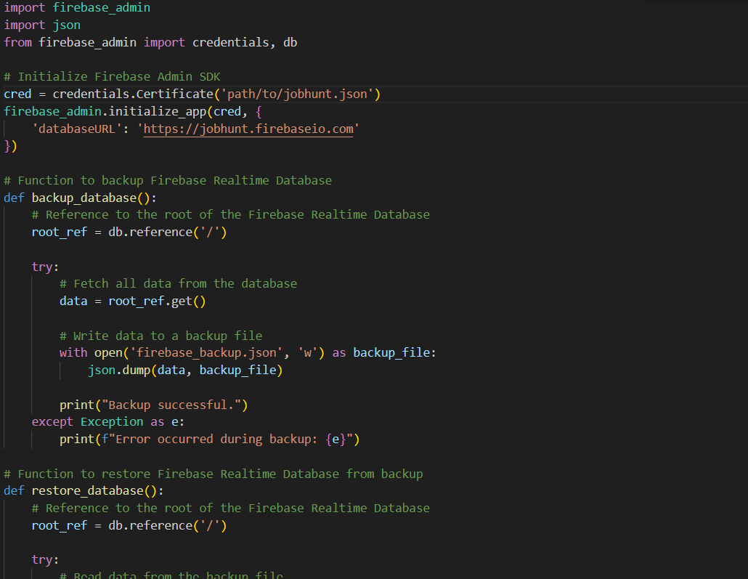

In the context of Job Hunt, SQLite is utilized for backup and recovery purposes to ensure the integrity and availability of critical application data. Here's how backup and recovery are implemented using SQLite:

**Responsive Design:**   
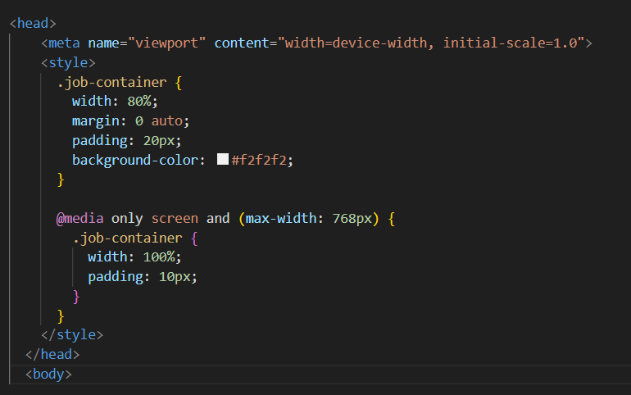

Responsive design is paramount for ensuring an optimal user experience across various devices and screen sizes when accessing the Job Hunt platform. Here's how responsive design principles are applie:

**Mobile-first Approach:** Job Hunt adopts a mobile-first approach to web design, prioritizing the development of a user interface that is optimized for mobile devices such as smartphones and tablets.

**Fluid Grid Layout:** A fluid grid layout is implemented to ensure that page elements dynamically adjust and reflow to fit the available screen space, regardless of the device's viewport size.

**Flexible Images and Media:** Images and media assets are optimized for responsiveness using techniques such as CSS media queries, fluid resizing, and resolution switching to adapt to different screen resolutions and aspect ratios.

**Viewport Meta Tag:** The viewport meta tag is included in the HTML document to instruct the browser to scale the page content appropriately based on the device's viewport width, ensuring consistent rendering across devices.

**CSS Media Queries:** CSS media queries are utilized to apply specific styles and layouts based on the device's screen size, orientation, and other characteristics. This enables the creation of device-agnostic stylesheets that cater to various viewing contexts.

**Progressive Enhancement:** Progressive enhancement techniques are employed to provide a baseline user experience on all devices while progressively enhancing functionality and aesthetics for devices with larger screens or more capable browsers.

By embracing responsive design principles, Job Hunt delivers a seamless and user-friendly experience to job seekers, enabling them to access.

**Compatibility Testing:**

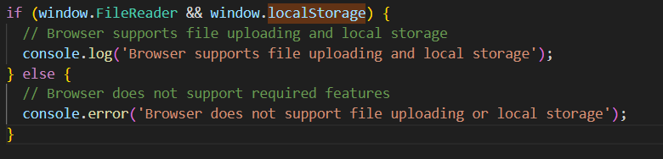

**Explanation:**

typeof window.FileReader !== 'undefined': This condition checks if the FileReader object is defined in the global window object. If it's defined, it implies that the browser supports the FileReader API.

console.log('FileReader is supported');: If the FileReader object is defined, this message is logged to the console, indicating that FileReader is supported in the current browser.

console.log('FileReader is not supported');: If the FileReader object is not defined, this message is logged to the console, indicating that FileReader is not supported in the current browser.

This approach is a form of feature detection, which is generally considered a best practice for determining browser capabilities. It allows your code to adapt dynamically based on the features supported by the user's browser, ensuring a more consistent and reliable user experience across different environments.

In your compatibility testing, you can use this technique to verify whether essential features or APIs required by your application are supported by the target browsers. If a feature is not supported, you can provide fallback mechanisms or informative messages to users, guiding them on how to proceed or suggesting alternative solutions.

**Adaptive Layouts:**

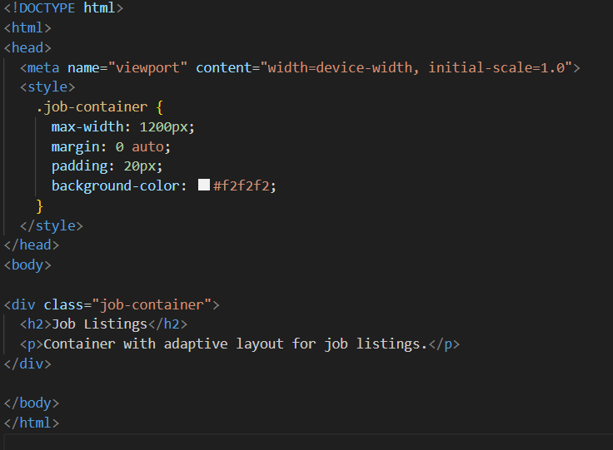

This container will adjust its layout based on the size of the screen it is displayed on.

**Touch-Friendly Interaction:**

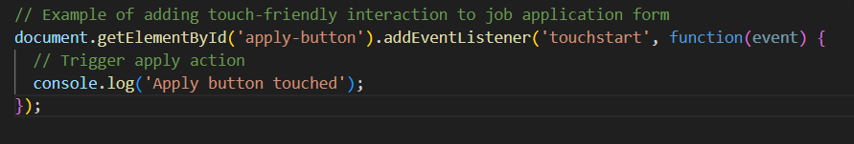

The code snippet likely involves an event listener that triggers a specific function when the user touches the "Apply" button on the form. This would enhance the user experience by making the application process more intuitive on touch screen devices.